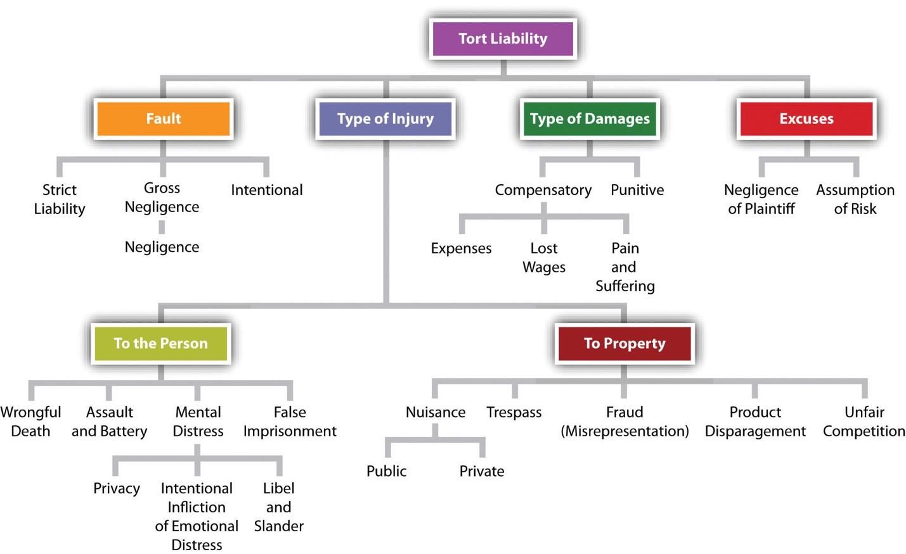
Tort Law: A Brief Overview and Its Challenges in Contractual Drafting
1. Introduction to Tort Law
Tort law is a branch of law that deals with civil wrongs. It allows individuals to seek compensation when someone’s wrongful conduct results in harm or loss. Tort law covers a wide range of issues, from personal injury to defamation, negligence, and even economic harm. The key principles of tort law include:
- Duty of care: The obligation to avoid causing harm to others.
- Breach: Violation of that duty through action or inaction.
- Causation: The need to prove the breach caused harm.
- Damages: Monetary compensation for the harm suffered.
Unlike contractual obligations, torts arise from duties imposed by law rather than those voluntarily assumed through an agreement. This means that torts can exist even when there is no contract between the parties involved.
2. Challenges of Drafting Clauses Around Tort Law in Contracts
While contracts are designed to outline agreed-upon obligations, tort law introduces external obligations that can impact contractual relationships. Drafting clauses to address tortious liability within contracts presents several challenges:
- Scope of Liability: Contract drafters must clearly define the scope of tort liability within a contract. For instance, parties often include indemnity or limitation of liability clauses to reduce exposure to potential tort claims. However, such clauses can be limited by public policy, especially in cases of gross negligence or intentional harm.
- Unforeseen Events: Torts often cover unforeseeable events, such as accidents or negligence. Drafting clauses to address these can be difficult because it’s challenging to predict every potential scenario where tort liability might arise. Clauses related to indemnity and insurance typically aim to allocate risks for such unforeseen events.
- Overlap with Contractual Obligations: Tort claims may sometimes overlap with breaches of contract, making it tricky to distinguish between contractual and tortious liability. Courts can sometimes allow tort claims in cases of professional negligence, even when there is a contract in place. This makes drafting exclusion clauses that bar tort claims complex.
- Varying Jurisdictional Interpretations: The interpretation of tort law and its application in contracts can vary greatly between jurisdictions. Drafting a contract that aims to limit tort liability must account for jurisdictional differences in how torts are treated, which increases the complexity of legal drafting.
3. Why There Is No Direct Equivalent in Civil Law Systems
In civil law systems (such as those in much of Europe and Latin America), tort law does not exist as a separate legal framework like in common law systems. Instead, civil law systems handle tort-like cases under the general principles of delict or extra-contractual liability.
- Codified Approach: Civil law systems rely on codified legal frameworks where most obligations, including those resembling torts, are defined within a statutory framework (e.g., the Civil Code). This provides a more predictable and structured approach, where judges apply the law based on written statutes rather than relying on judicial precedent.
- Unified Liability Structure: In civil law systems, contractual and non-contractual liability are often addressed together under a unified framework, blurring the lines between obligations arising from contracts and those arising from other sources like negligence. This reduces the need for separate tort law provisions as found in common law jurisdictions.
- Less Reliance on Precedent: Common law systems rely heavily on precedent, where tort law evolves through court decisions. Civil law systems, by contrast, rely on codified principles that are more rigid, leading to fewer disputes about interpretation. As a result, the need to draft detailed clauses around tortious liability is less common in civil law systems.
Tort law presents unique challenges in contract drafting, particularly in common law systems where tort and contract law operate independently. Drafters must carefully consider how to manage potential tortious liability, especially for unforeseeable events and in different jurisdictions. Civil law systems, on the other hand, provide a more structured approach, where delict and contractual liability are governed together, minimizing the need for separate clauses related to torts. Understanding these differences is crucial for legal professionals working across multiple legal systems.

