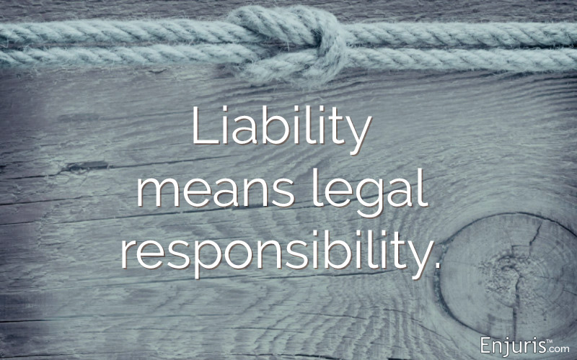Liabilities vs. Responsibilities, Covenants, Warranty, Guarantee, and Indemnification: A Comparative Overview
In legal and business contexts, terms such as liability, responsibility, covenant, warranty, guarantee, and indemnification are often used interchangeably, but they represent different obligations. Understanding the distinctions is crucial for interpreting contracts, determining risks, and managing expectations. Below is an overview of these concepts, how they differ, and an explanation of indemnification.
1. Liability
Liability refers to a party's legal obligation to compensate for harm or loss caused by its actions or omissions. It often involves monetary damages and arises from breaches of law, contract, or tort (civil wrongs like negligence). Liabilities can be strict, vicarious, or limited:
- Strict Liability: Imposed without fault, often in cases of inherently dangerous activities.
- Vicarious Liability: When one party is held liable for the actions of another (e.g., an employer for employee misconduct).
- Limited Liability: Typically found in corporate structures, where liability is restricted to the amount of capital invested.
Liability typically involves financial consequences and is enforceable through legal mechanisms.
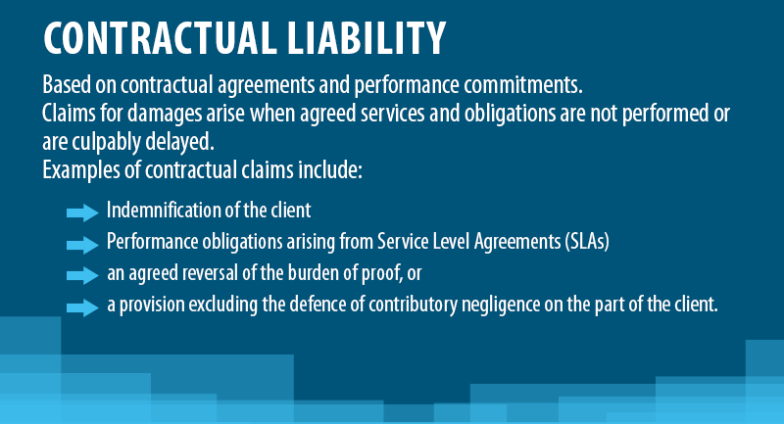
2. Responsibility
Responsibility refers to a party's duty to perform certain tasks or actions. Unlike liability, responsibility does not necessarily carry a legal obligation to compensate for harm. Responsibilities can be moral, contractual, or organizational. For instance, an employee may be responsible for completing specific tasks but not legally liable for the company's outcomes.
The distinction lies in that responsibility pertains to performance and actions, whereas liability involves legal consequences if obligations are not fulfilled.
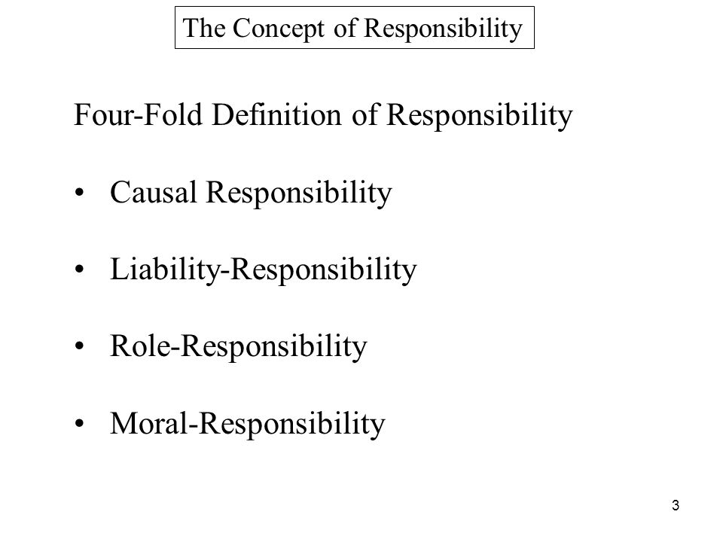
3. Covenant
A covenant is a formal agreement or promise within a contract that commits a party to do or not do something. Covenants are binding commitments and are often found in legal documents like real estate transactions, financial agreements, and deeds.
- Affirmative Covenants: Require a party to take action (e.g., maintain insurance).
- Negative Covenants: Prohibit certain actions (e.g., not borrowing beyond a certain limit).
If a covenant is breached, it can lead to liability or other contractual remedies, but it differs from a warranty in that it is a promise about future conduct rather than the state of a current fact.
4. Warranty
A warranty is a promise or assurance that certain facts or conditions are true at the time of the contract, often related to product quality or performance. Warranties can be:
- Express Warranties: Explicitly stated in the contract, assuring specific conditions.
- Implied Warranties: Automatically applied under law (e.g., the implied warranty of merchantability).
If a warranty is breached (e.g., a product does not function as promised), the injured party may be entitled to repairs, replacements, or compensation. Unlike a covenant, a warranty applies to the present condition or quality of goods/services.
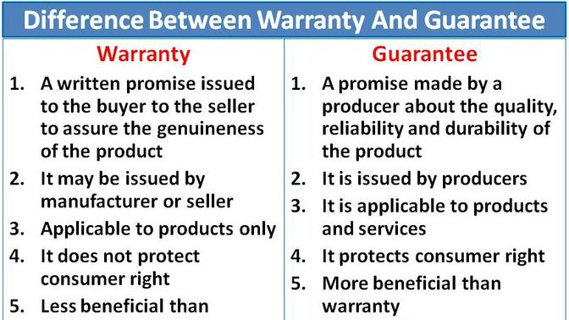



5. Guarantee
A guarantee is a contractual assurance that a party (the guarantor) will fulfill another party’s obligation if the latter fails to do so. It often involves financial or performance commitments and is typically found in lending agreements or service contracts.
- Personal Guarantees: The guarantor personally ensures repayment or performance.
- Corporate Guarantees: A company guarantees the obligations of another entity.
While a warranty relates to the quality of goods/services, a guarantee is a promise of backup performance or payment. If the principal party defaults, the guarantor is liable to fulfill the obligation.
6. Indemnification
Indemnification is a contractual agreement where one party (the indemnitor) agrees to compensate or "make whole" another party (the indemnitee) for losses or damages incurred. It is often used as a risk-shifting mechanism, ensuring that the indemnified party is protected from certain types of liabilities or losses, including lawsuits, claims, or financial losses.
Indemnification can cover a variety of circumstances, such as:
- Third-Party Claims: When a third party sues or claims damages, the indemnitor agrees to cover the costs.
- Direct Losses: The indemnitor agrees to reimburse the indemnitee for direct losses caused by a breach of contract or other specified risks.
- Hold Harmless Provisions: Sometimes indemnification clauses include language that protects the indemnitee from liability for certain actions.
Key Differences Between Indemnification and Liability
- Scope: While liability generally involves direct compensation for damages caused by a breach or harm, indemnification shifts the responsibility for paying those damages from one party to another. In an indemnification, the party being indemnified (indemnitee) may not have caused the harm but is being protected from its consequences.
- Third-Party Involvement: Indemnification often addresses third-party claims, meaning the indemnitor takes on the responsibility for lawsuits or claims made by third parties against the indemnitee. Liability, on the other hand, usually arises directly between the parties to the contract.
- Risk Transfer: Indemnification is more proactive and serves as a risk transfer mechanism, protecting a party from potential future liabilities. Liability is the legal outcome when a party is found responsible for damages or harm.
Key Differences Between Indemnification and Other Concepts
- Indemnification vs. Warranty: A warranty is a promise regarding the state of a product or service, while indemnification involves compensation for losses or damages, including third-party claims.
- Indemnification vs. Covenant: A covenant is a binding promise to do or not do something, whereas indemnification provides financial protection against specific risks, even if covenants are breached.
- Indemnification vs. Guarantee: A guarantee involves a third party stepping in to fulfill an obligation, often a payment or performance duty, while indemnification protects a party from bearing the costs of specific damages or liabilities.
Summary of Differences
- Liability: Legal obligation to compensate for damages.
- Responsibility: Obligation to perform specific tasks, without direct financial consequence.
- Covenant: A promise within a contract, binding future conduct.
- Warranty: An assurance about current product/service quality or performance.
- Guarantee: A promise to fulfill another party’s obligation if they fail.
- Indemnification: A contractual obligation to compensate another party for losses or damages, particularly in third-party claims.
In summary, liabilities arise from obligations or wrongful actions, responsibilities are duties to act, covenants are promises, warranties are assurances of quality, guarantees are backup promises, and indemnification involves risk-shifting for losses. Understanding the nuances of these terms is critical for managing legal and financial risks effectively.
